W-16

**YEAR 12 PHYSICS**

**ASSIGNMENT 4 - ELECTROMAGNETISM**

Name: Mark: 

1. Drawn below are diagrams representing three fields. Use the information contained in the blanks in the following sentences. Any field diagram can be used more than once.

(5 marks)

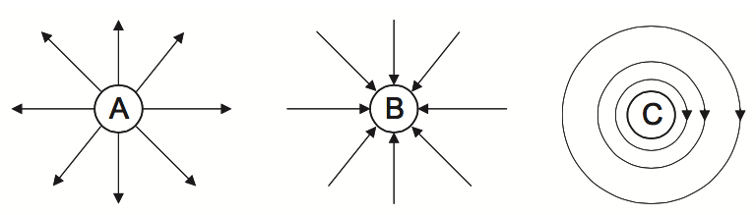

Diagram could represent the gravitational field of a mass.

Diagram could represent the electric field around a positively charged particle.

Diagram could represent the electric field of a negatively charged particle.

Diagram represents a current carrying wire directed the page.

2. An electron moving with an initial velocity u has initial kinetic energy EKi . It enters a uniform electric field with field strength ***E***, as shown in the diagram below. The electron’s final kinetic energy EKf is equal to 4EKi.

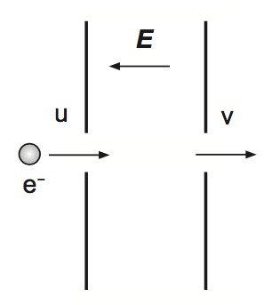

The electric field strength is now doubled. If another electron, having initial kinetic energy EKi enters the field, determine this electron’s final kinetic energy in terms of EKi.

You should ignore the effects of gravity. (4 marks)

3. Draw the resultant electric field with at least 5 lines for each of the following situations.

(4 marks)

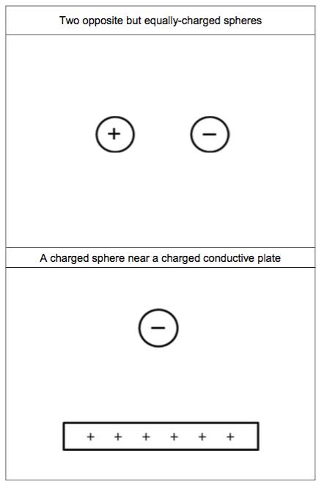

4. An ammeter is a device that is used to determine the magnitude of an electric current. The unknown current is passed through a coil of wire in a magnetic field. The turning effect of the current-carrying coil is balanced by a spring and a corresponding value is read from the meter.

(a) Use the photograph below of an ammeter’s scale to determine the magnitude of the current passing through it, as well as the absolute and relative uncertainty for this value. (3 marks)

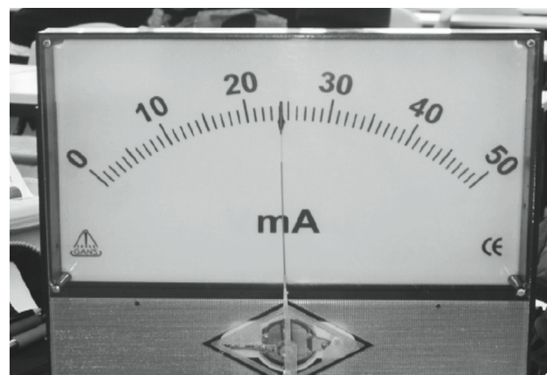

Current: mA

Absolute uncertainty:

Relative uncertainty:

(b) A simplified diagram representing one current-carrying wire of the ammeter’s coil between two magnets is shown below. Draw at least ***five*** field lines to show the resultant magnetic field between the magnets. (4 marks)

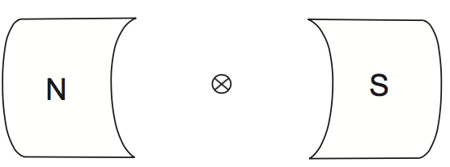

(c) Calculate the magnitude of the force, in newtons, acting on the wire carrying a current of 1.45 A in the simplified diagram on page 3, given that the magnetic field strength is 4.25 × 10-2 T and the length of the wire in the field is 2.50 × 10-2 m. (3 marks)

(d) The actual ammeter shown has 250 turns of wire that form a square coil with sides of 3.20 × 10-2 m. Determine the magnitude of the current in amperes, given that the spring provides a restoring torque of 2.65 × 10-2 N m in the magnetic field strength of 4.25 × 10-2 T. (4 marks)

5. Jake wanted to determine the strength of a magnetic field by conducting an investigation. In this investigation, two identical cylindrical permanent magnets, each 2.0 cm in diameter, were placed opposite each other on either side of an aluminium channel. A current was passed along a 20 cm copper rod, which in turn was placed perpendicularly in the magnetic field. The interaction between the permanent magnets and the current-carrying wire produced a downward force acting on the magnets, which was measured using a digital balance. Photographs of the equipment are shown below, as is a schematic diagram of the circuit.

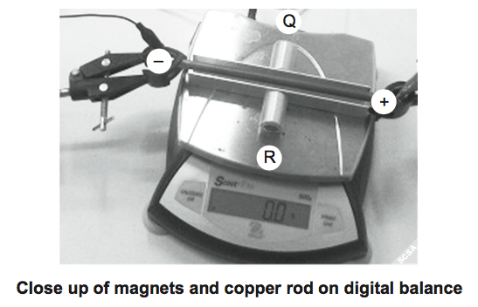

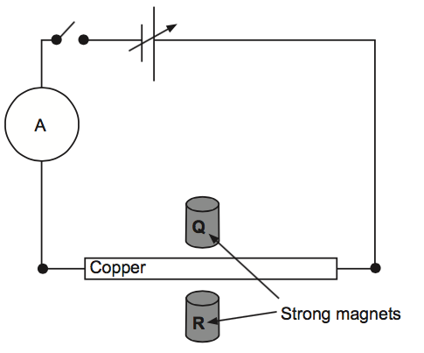

(a) Using the photograph above, for magnets labelled Q and R, write either ‘North’ or ‘South’ in the space below to indicate which pole the magnet would need to have next to the channel to provide the magnets with a force directed downward (into the pan of the balance).   (2 marks)

For magnet Q, the pole would be next to the channel.

For magnet R, the pole would be next to the channel.

(b) A table of results for this investigation is shown below.

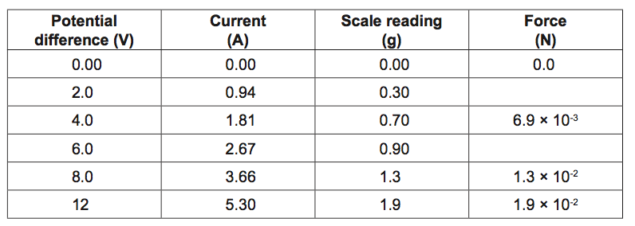

(i)   Complete the last column in the table above with values expressed to two significant figures. (2 marks)

(ii)   Use the data from the table to plot a straight-line graph on the grid provided, demonstrating the relationship between the current and force. (4 marks)

(iii)   Use your graph to determine the force that should be measured when a current of 4.0 A flows through the copper rod. Express your answer using appropriate significant figures. (3 marks)

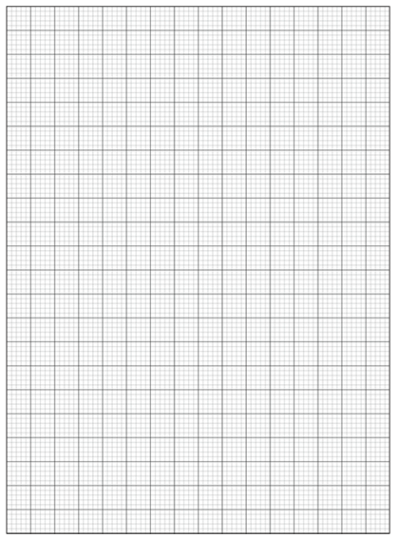

(iv)   Determine the gradient of your line of best fit. Include units in your answer.  (3 marks)

(v)   Use your gradient to determine the experimental value of the magnetic field strength. Include units in your answer. Show all workings. (4 marks)

6. An electron gun is a very important component of many devices, including particle accelerators, electron microscopes and cathode-ray tubes. A schematic diagram of an electron gun is shown below.

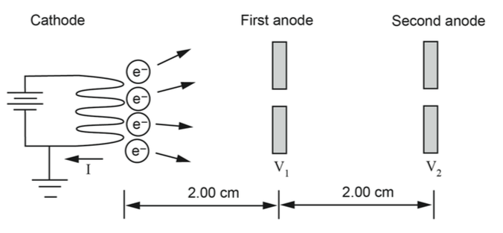

Assume the average initial velocity of a thermal electron is zero. The anode voltages are  V1= 1500 V and V2 = 4500 V and the distances between the cathode and anodes are as shown above.

(a) Calculate the velocity in m s-1 of the thermal electrons as they pass through the first anode. (4 marks)

(b) Calculate the average acceleration in m s-2 of an electron in the region between the cathode and the first anode. (3 marks)

(c) Complete the sketches that qualitatively represent the situation on the axes below. The first graph, of distance versus potential difference, has been completed for you. (6 marks)

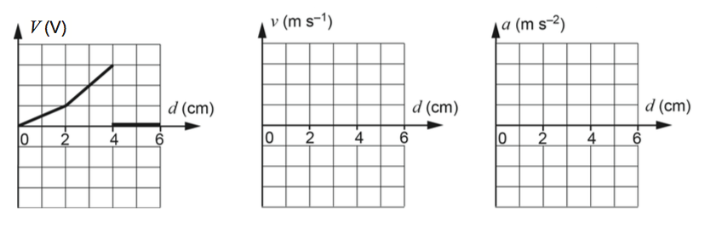

(d) Calculate the electrical work done by the electric field in moving one electron from the first anode to the second anode. Include units with your answer. (3 marks)

**7.** An electron moving at 0.900c enters a region of space and follows a path that has a constant radius of 0.348 m while in the magnetic field shown on the diagram, before striking a target anode.

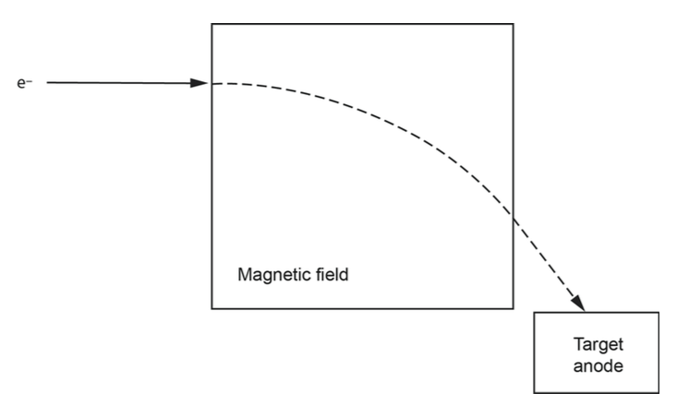

(a)   Draw the magnetic field enclosed in the indicated space. (2 marks)

(b)   (i) Derive the formula . (3 marks)



(ii) Use this formula to calculate the field strength needed to direct an electron along this path. Include units in your answer. (4 marks)

(iii) Describe how each of the changes below affect the charged particle’s path in the magnetic field. (4 marks)

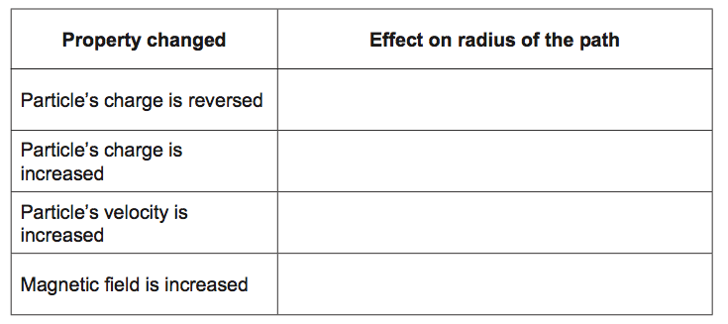

8. In the diagram below, the arrow represents a stream of electrons, moving with velocity *v*, entering a solid copper strip. The electrons are moving in the direction M to N. A magnetic field of strength *B*, perpendicular to the strip is switched on.

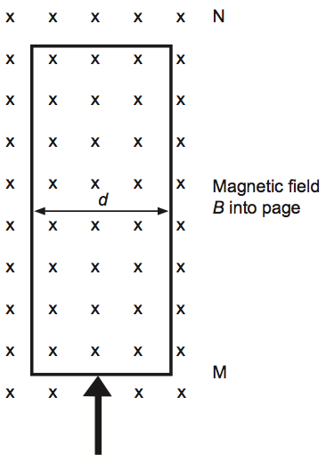

(a) Explain why electrons will begin to collect on the right hand edge of the strip and why an electric field develops across the strip. Express the voltage (V) due to the electric field in terms of the electric field strength (E) and the distance across the strip (d).

(4 marks)

The phenomenon of a voltage being produced across a current carrying conductor due to the presence of a magnetic field is called the Hall effect, and the voltage is termed the Hall voltage. It is utilised in probes used to measure magnetic field strength.

(b) For the probe in the diagram below, draw an arrow to indicate the direction of the electric field in the strip. (1 mark)

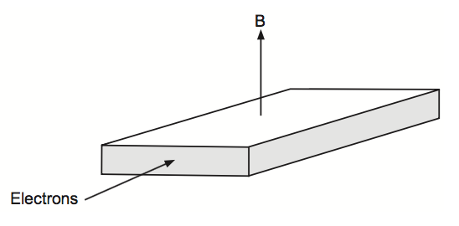

(c) The Hall voltage can be calculated using the equation 

where  *I* = electric current

*B* = magnetic field strength

*t* = thickness of the strip

*n* = number of electrons per m3

*e* = charge on an electron



Calculate the magnetic field strength when *V* = 2.25 mV, *I* = 1.80 A, *t* = 1.25 × 10-4 m and *n* = 1.52 × 1025 m-3. (3 marks)

(d) Calculate the magnetic force exerted on the electrons if they are moving with velocity 1.17 m s−1. (3 marks)